SPRINT - 4

|  |  |
| --- | --- |
| Date | 19 November 2022 |
| Team id | PNT2022TMID11798 |
| Project name | Real Time River Water Quality Monitoring And  Control System |
| Maximum marks | 20 marks |

In Sprint 4 , The user interacts with the ui.

NODE RED FLOWS :

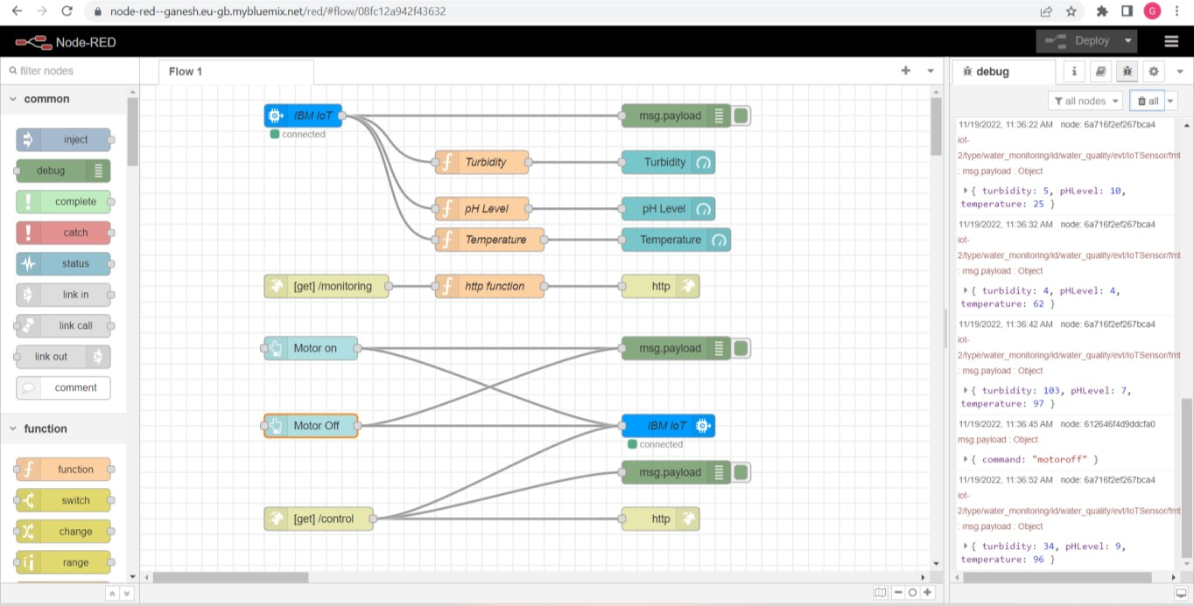

TURBIDITY :

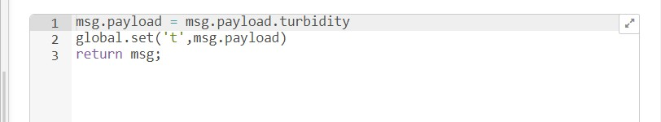

pH LEVEL :

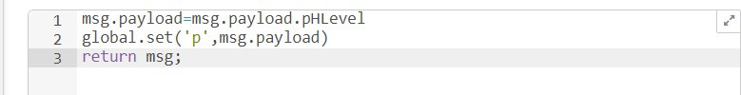

TEMPERATURE :

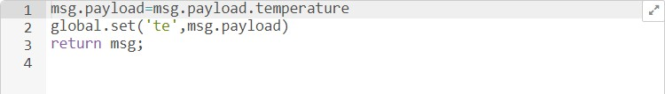

OUTPUT IN NODE RED :

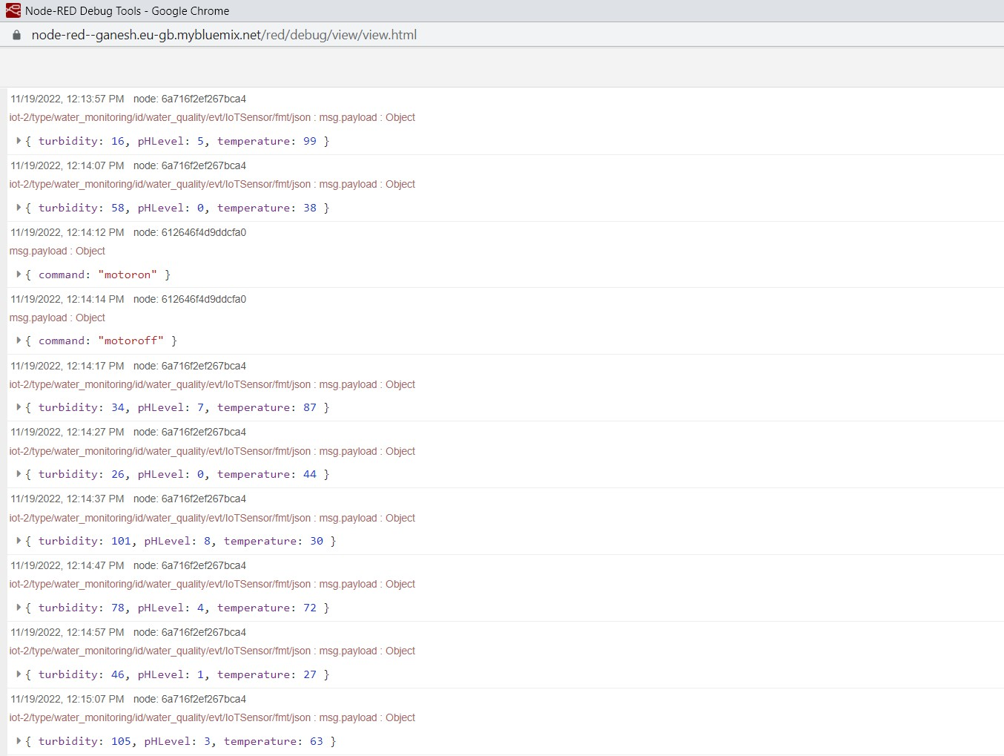

WEB UI :

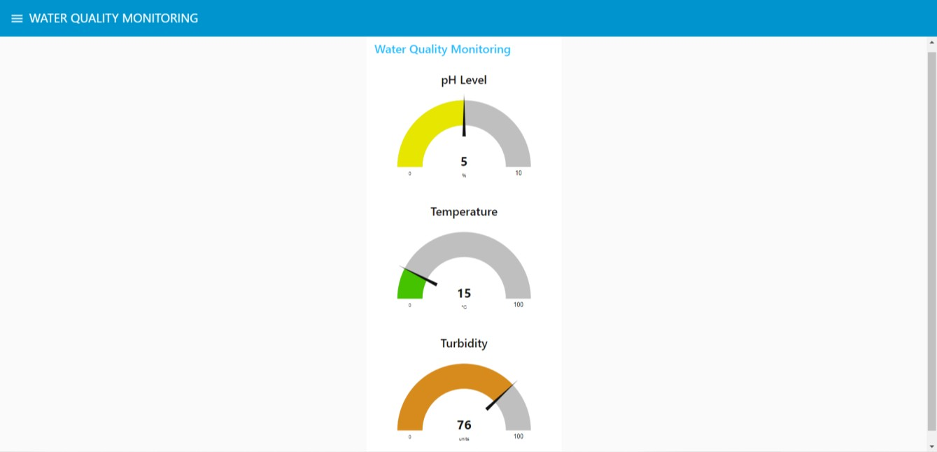

MOTOR CONTROL SYSTEM :

